Simulink → ADT Copyscript
Copying Simulink-generated files is almost easy with the help of two scripts, copyfiles.sh and copysimulinkfiles.m.

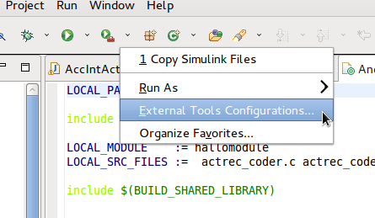
Eclipse External Tool Setup
Set up the copyfiles.sh shell script as external tool in Eclipse. Set /bin/bash as Location and use ~/copyfiles.sh ${project_loc}/jni as arguments (change so the location of your copyfiles.sh file is correct).

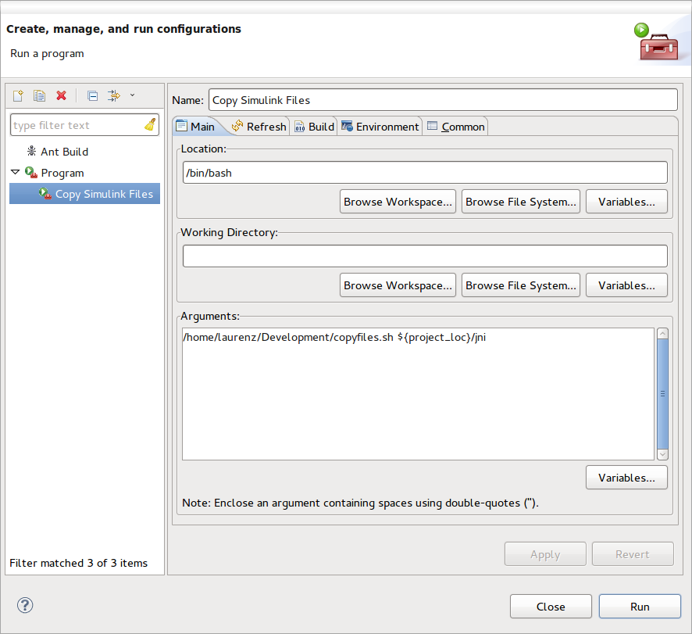

Usage
After succesful code generation in Simulink, run the copysimulinkfiles.m Matlab script. This will save the location of the generated files of the active simulink model to ~./simulinkfilecopy.
Next, run the copyfiles.sh shell script in Eclipse by clicking the “Run external tool” button (). The script will copy the Simulink-generated files to your active Android project's jni folder and update the makefile.

Troubleshooting

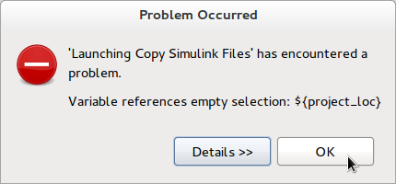
No Project Selected
You have to select a project in the Package explorer view in Eclipse before running the external tool. Otherwise you will get this message.

No JNI Folder
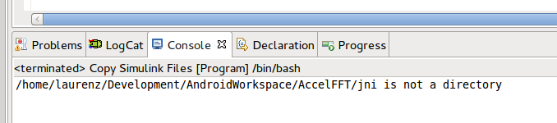
If your Android App doesn't have an jni folder, you will get this message. This is the case if you haven't added native support to your project yet.

